Name: Mohamed Gamal Saleh Abd-El-Nabi Soliman

B.N: 684

Edu mail: muhammed195762@feng.bu.edu.eg

Topic: Programming Languages

Course code: ECE001

**Application Brief**

Computer programming language is the language that includes a set of instructions that produce various kinds of outputs. These instructions can be executed directly when they are in the computer manufacturer. There are a lot of programming languages such as C++, FORTRAN and SQL. (C++): is an important language for education and industrial programming. (FORTRAN): this language is used for numeric and scientific computing. (SQL): this language is the basic language for relational database systems.

There are many types of programming languages such as: Machine language: This type is a collection of binary digits that the computer can read and interprets. The exact machine language for a program can differ by operating system on the computer. Algorithmic languages: These languages were the first high-level languages. They are designed to express mathematical calculations. Theses languages are (FORTRAN- ALGOL- LISP- C). Object-oriented languages: They are high-level computer programming languages which perform objects and their related procedures within the programming context to make software programs. These languages are (C++- Ada- Java- Visual Basic).

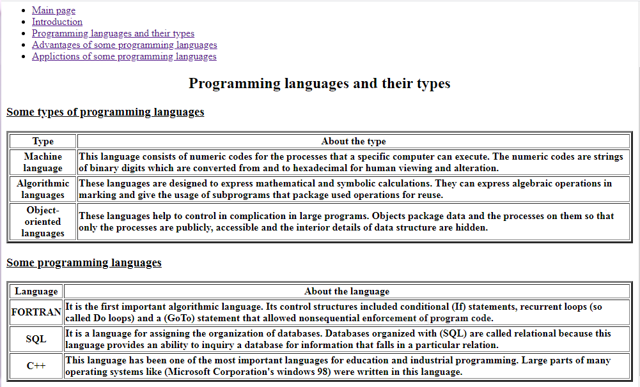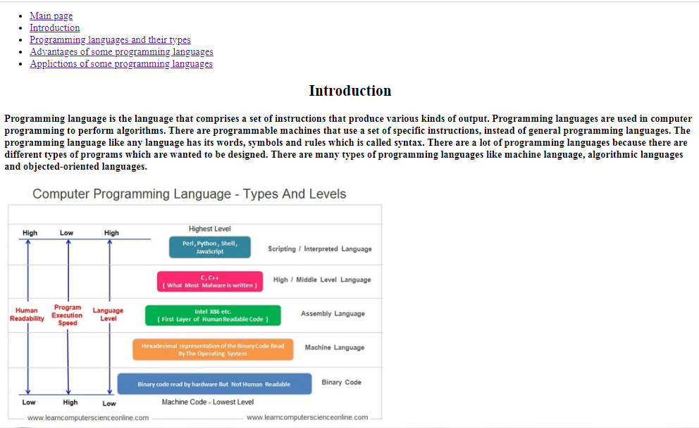**Screenshots**

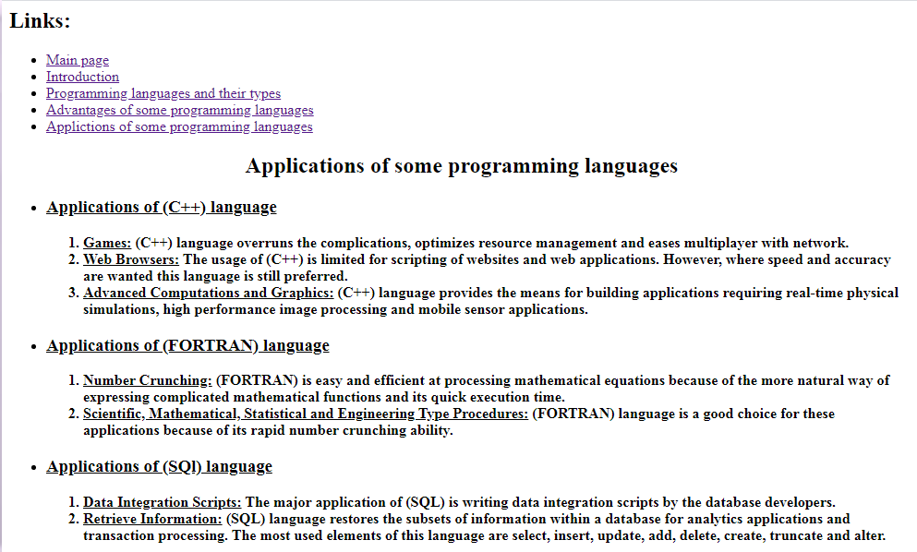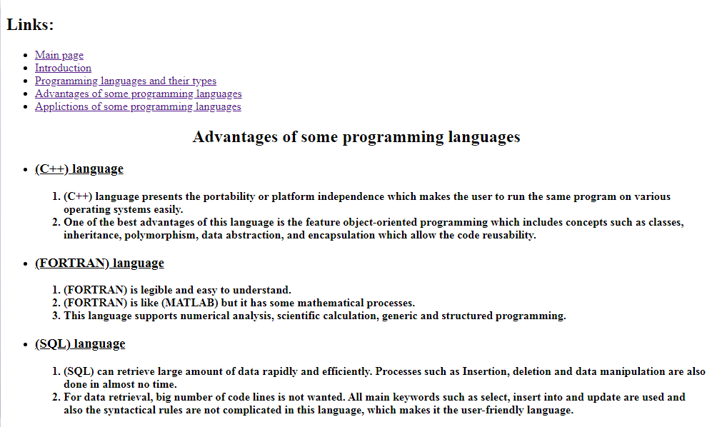

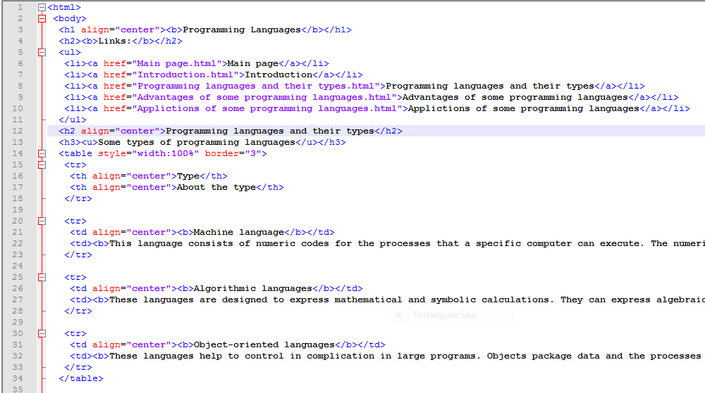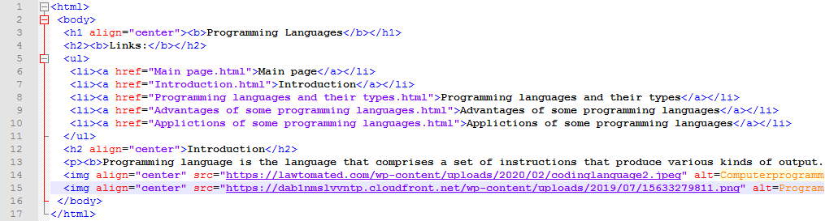**Source Code**

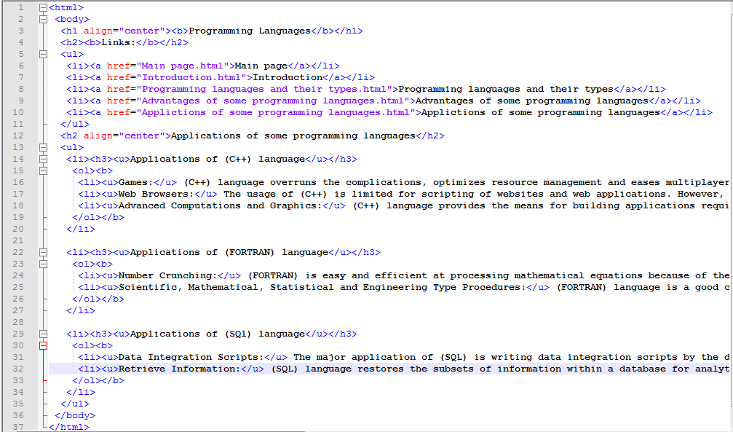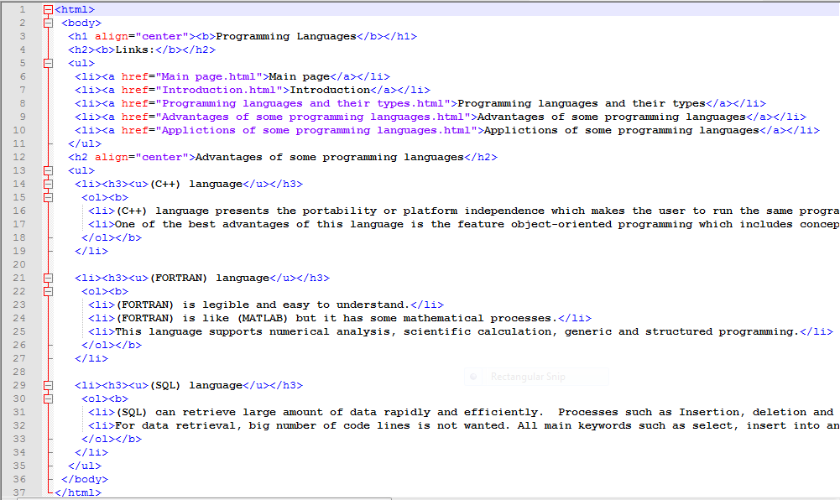

**References**

* Stroustrup, Bjarne (2013). The C++ Programming Language. Addison Wesley.
* "Chapel spec (Acknowledgements)". Cray Inc. 1 October 2015.
* Ettinger, James (2004) Jacquard's Web, Oxford University Press
* David A. Schmidt, The structure of typed programming languages, MIT Press, 1994
* "Structured Query Language (SQL)". International Business Machines. October 27, 2006